**Standard Operating Procedure (SOP) Document**

**Azure VM Restoration SOP**

**Document Owner: Cloud Ops**

**Author: Santosh Pawar**

**Editor: Hirinder Mulwani**

**Document Number: R.Ai-SOP012**

**Document Revision Number: v1.0**

**Effective Date: Oct 2024**

**Work Instructions for Azure VM Restoration - In Application Issue**

1. **Create New storage account in same region where RSV is located**

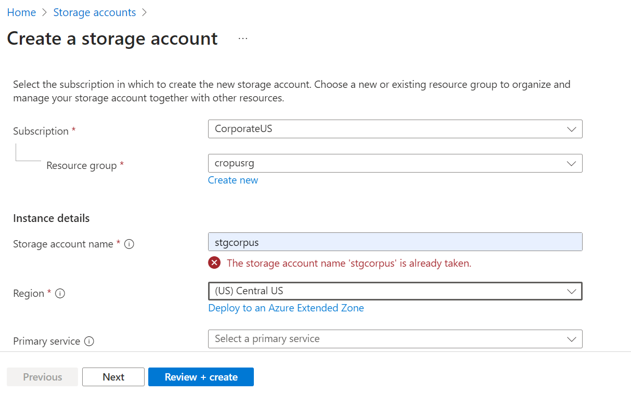

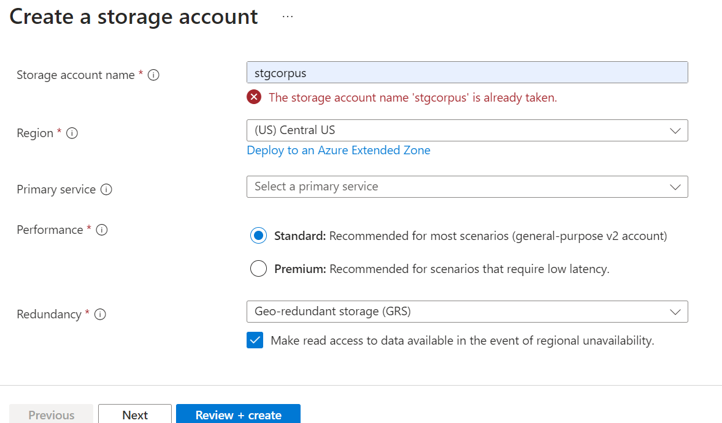

1. **Click on Review + create.**
2. **Now go to Backup and select restore point and click on “Restore VM”**

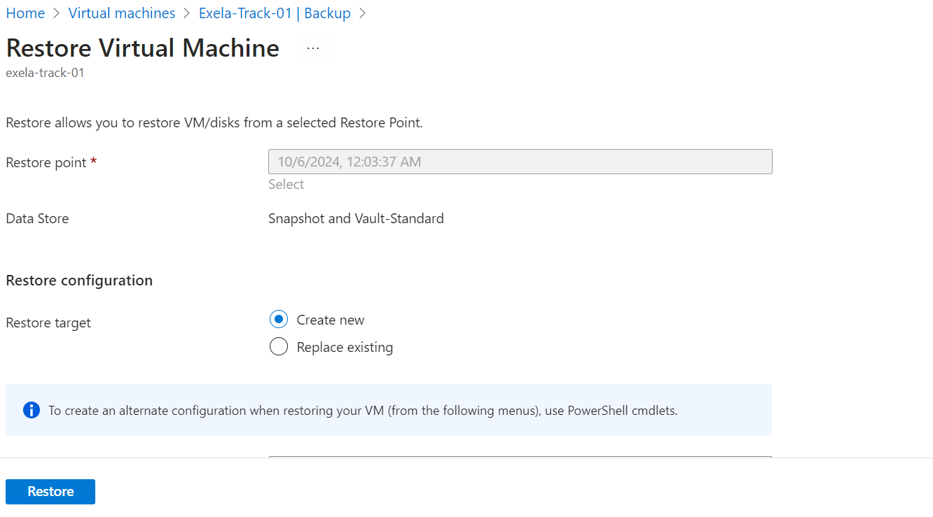

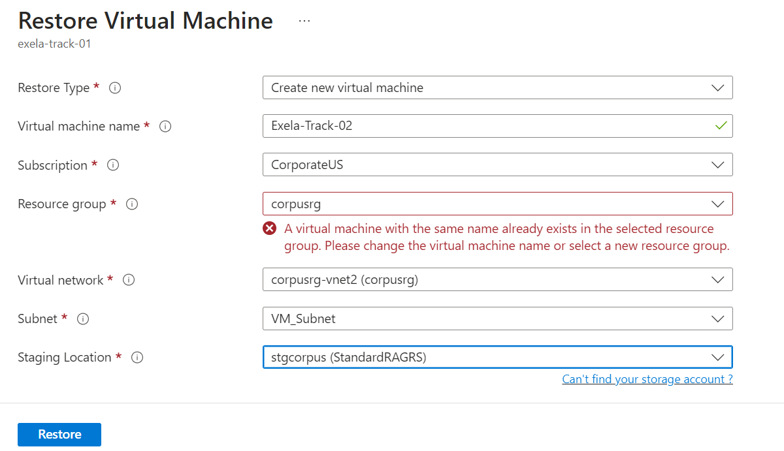

1. **Click On Restore.**

**New VM (Exela-Track-02) will be restored/created with host name in OS same as old VM Exela-Track-01 and different IP.**

1. **To maintain the same private IP as before, shutdown the old VM and change the IP of the old VM in Network Interface as static and then provide same IP of old VM to this new VM in Network Interface as static as shown below.**

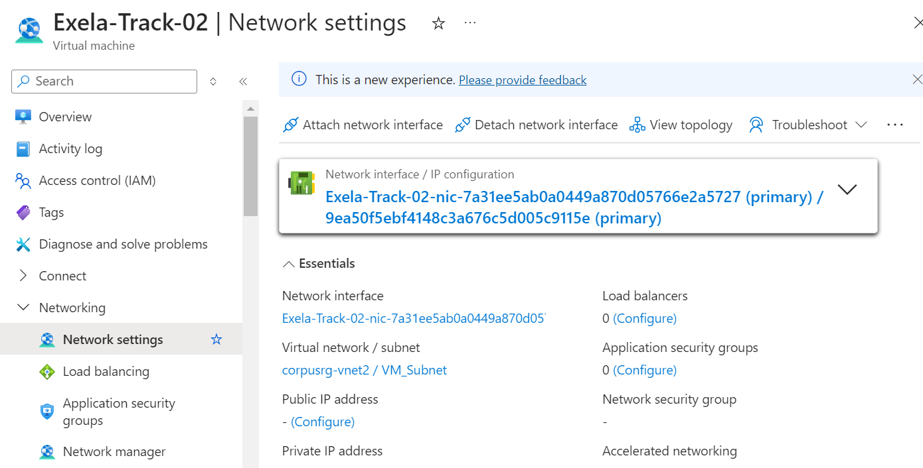

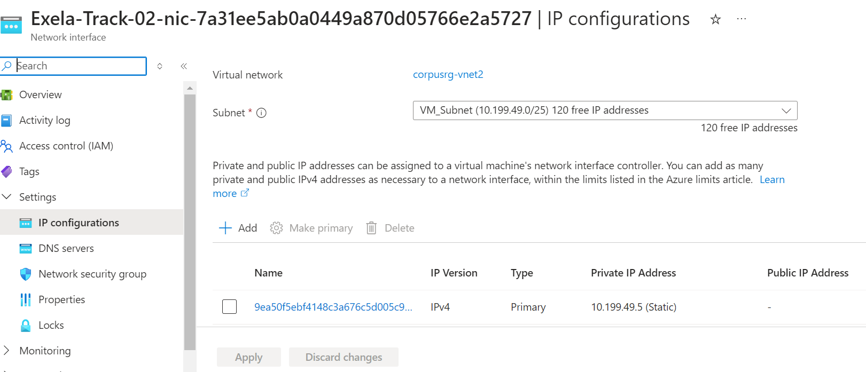

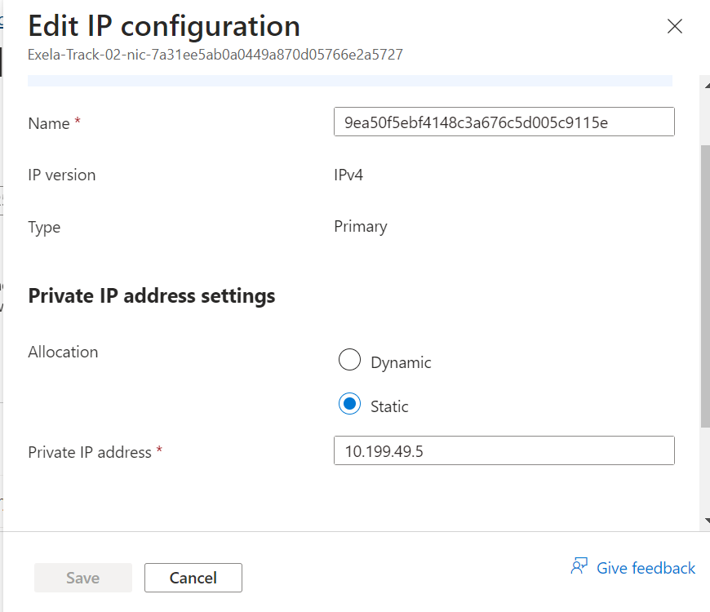

1. **Click on Save.**
2. **Remove Akamai and re-connect the new VM to domain.**

# **Document Control**

**Summary of Changes**

|  |  |  |  |  |  |
| --- | --- | --- | --- | --- | --- |
| **Revision Number** | **Revision Date** | **Author or Reviser** | **Reviewer** | **Approver** | **Nature of Change** |
| v1.0 | 21-Oct-24 | Author – Santosh Pawar | Balamurugan P | Tanveer Ahmed | First Draft |

* **Note:**  A change bar (|) in the left-hand margin indicates that the associated material has changed since the previous revision of the document. Editorial/Formatting changes are not marked. Full release updates do not use change bars if they result in the majority of the document being rewritten.

**Document Review Plans**

* Necessary reviews and updates to this document are defined below:
* Following a regularly scheduled review, at least once annually
* As required to correct or enhance information content
* Until the applicable current annual review is completed, the last signed off version will remain applicable for all compliance, client operations and audit purposes.

**How to Find the Latest Revision of this Document**

* The latest revision of this document may be obtained as follows:
* Access in the <Knowledge repository / document database>

**Document Distribution and Notification**

* Printed copies are for reference only and are not controlled
* Obtain and use only the current, approved document