Knowledge Article for Printshop deployment

Step 1 - The developer needs to do a docker push to the GCP repository (artifact-registry), verify the image, and get the Image tag shown below images.

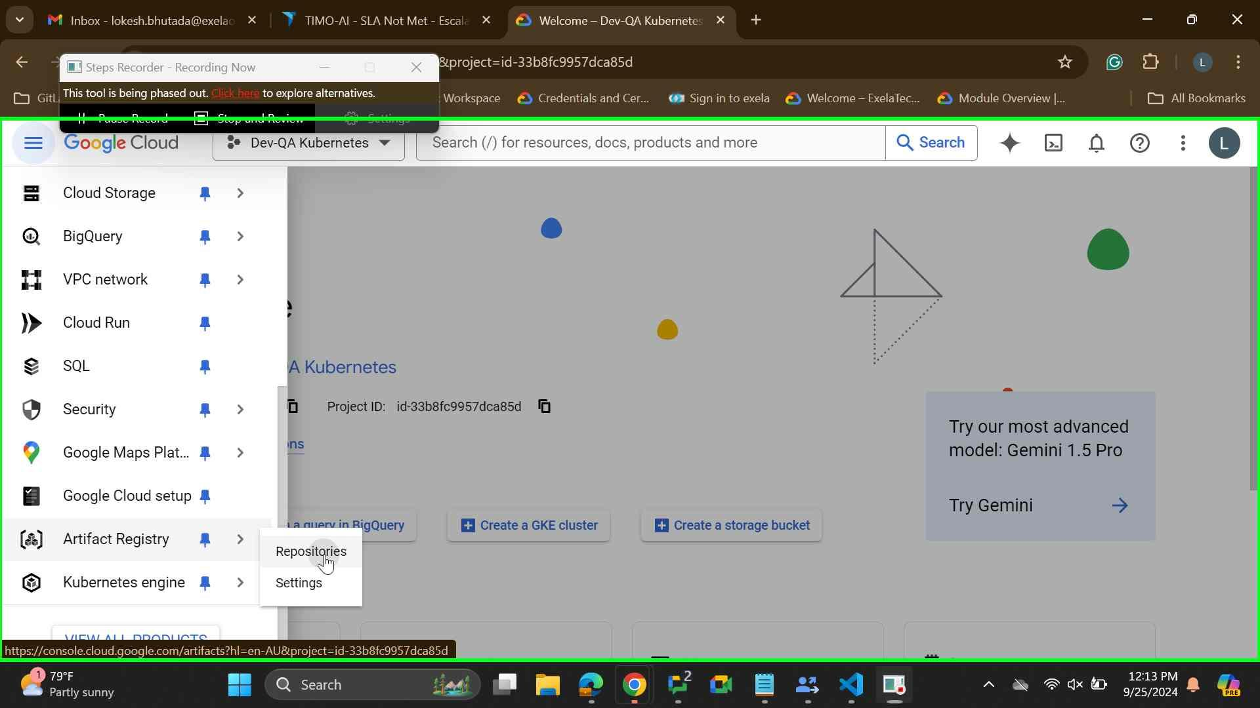

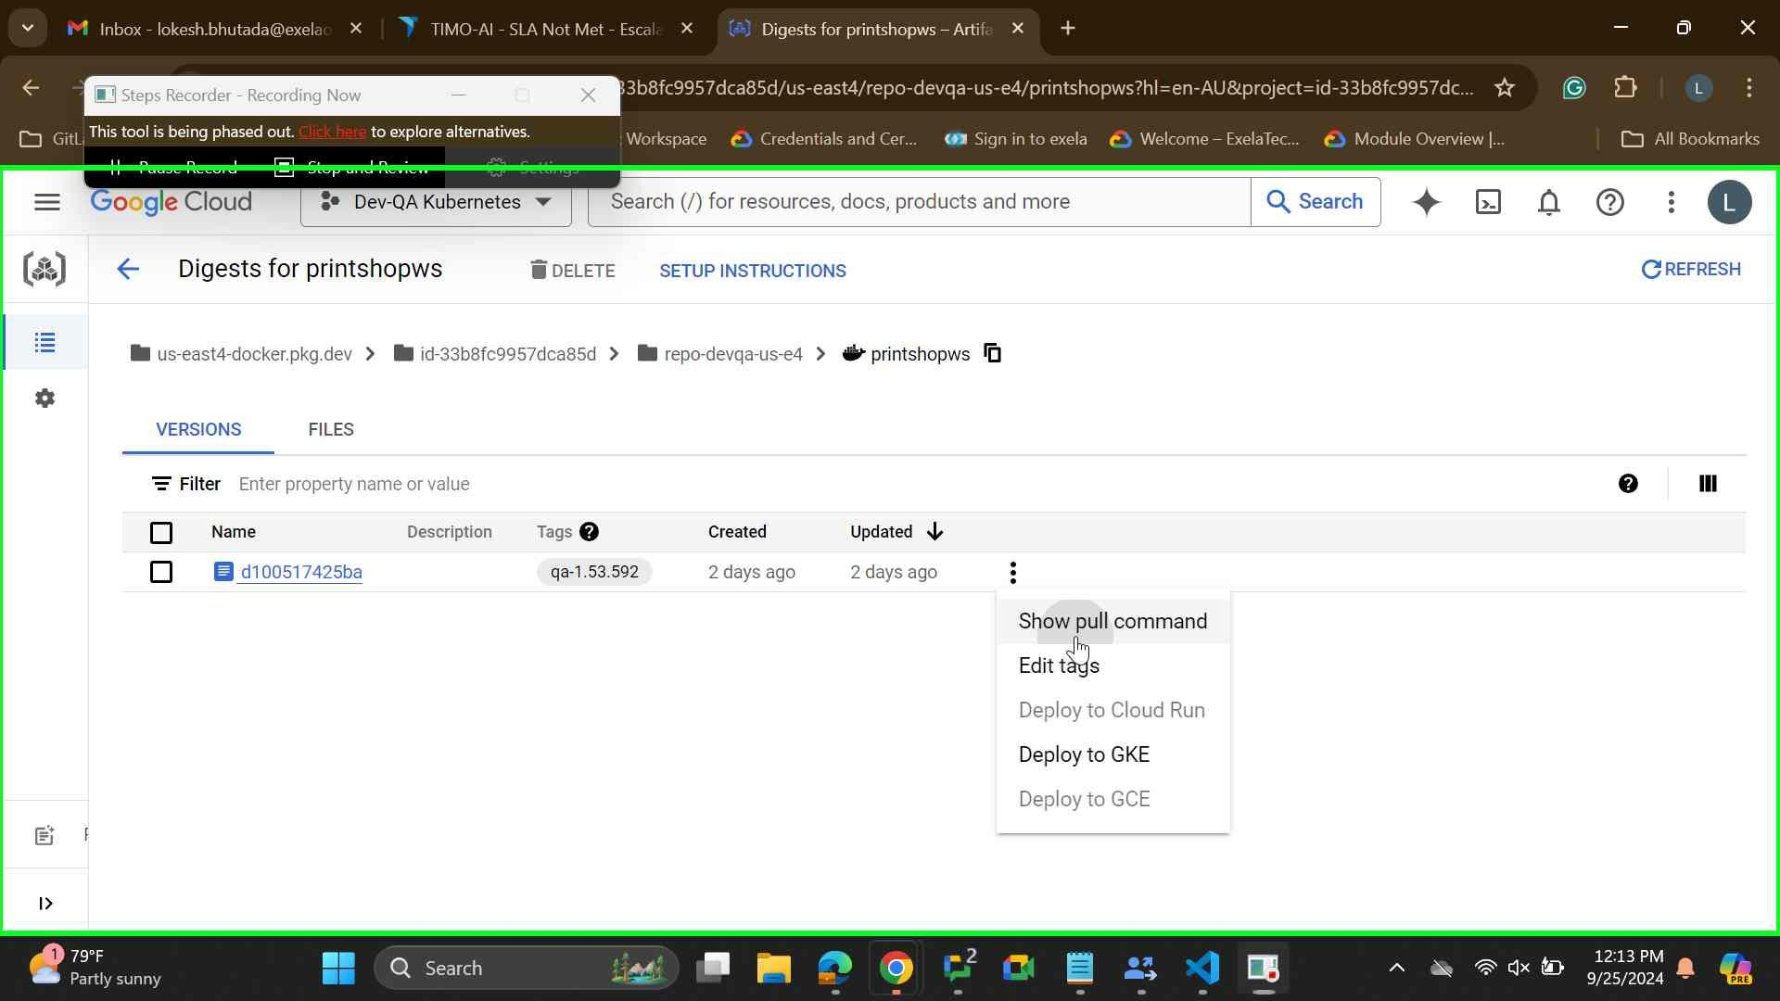

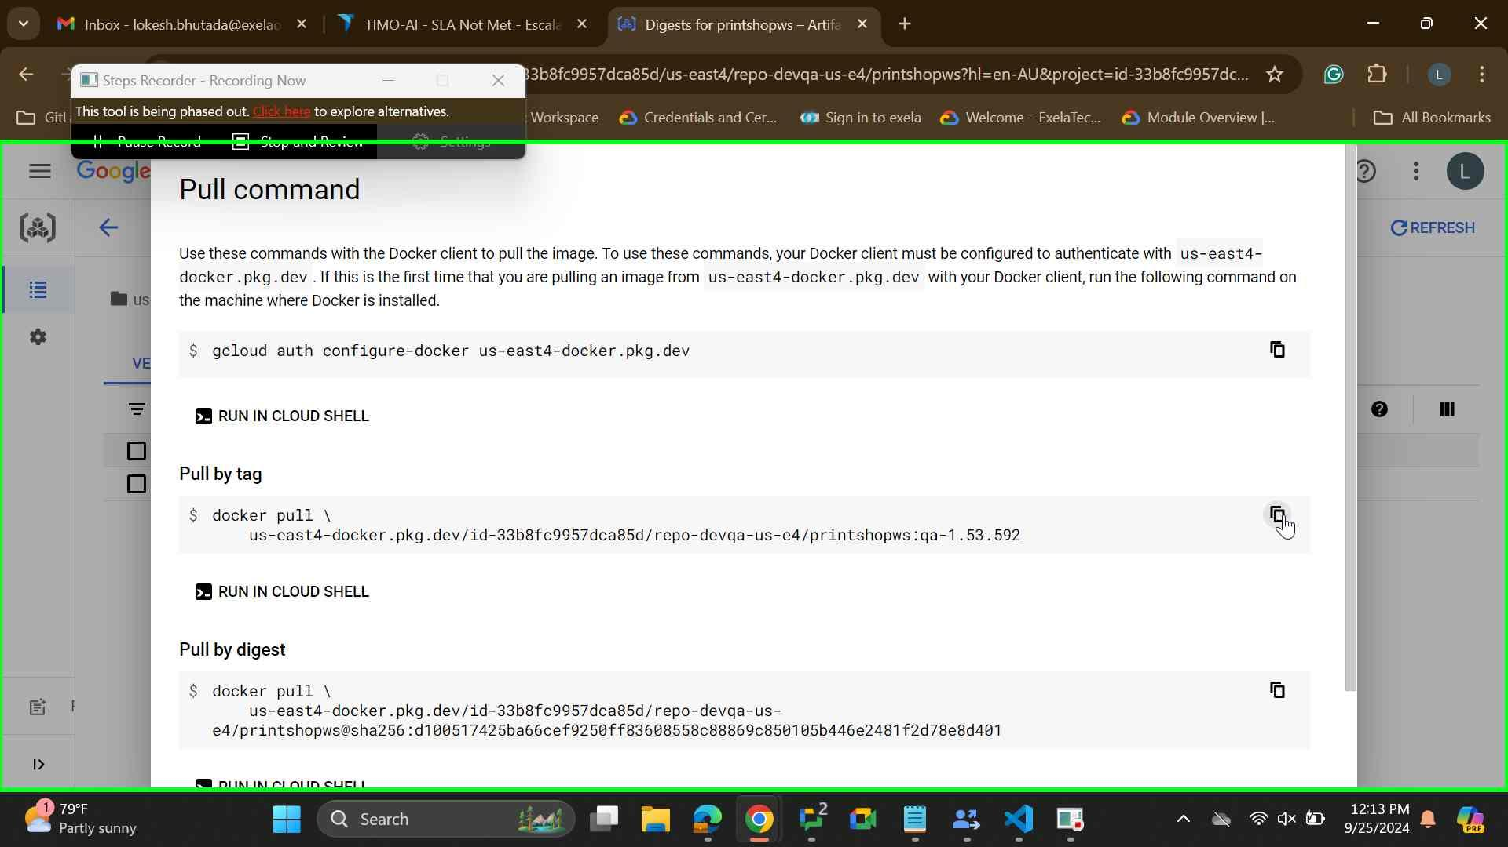

Step 2: After getting the docker image tag from the registry edit the YAML with the required parameters like (port no, DBurl, DBusr/password) and update the image Tag

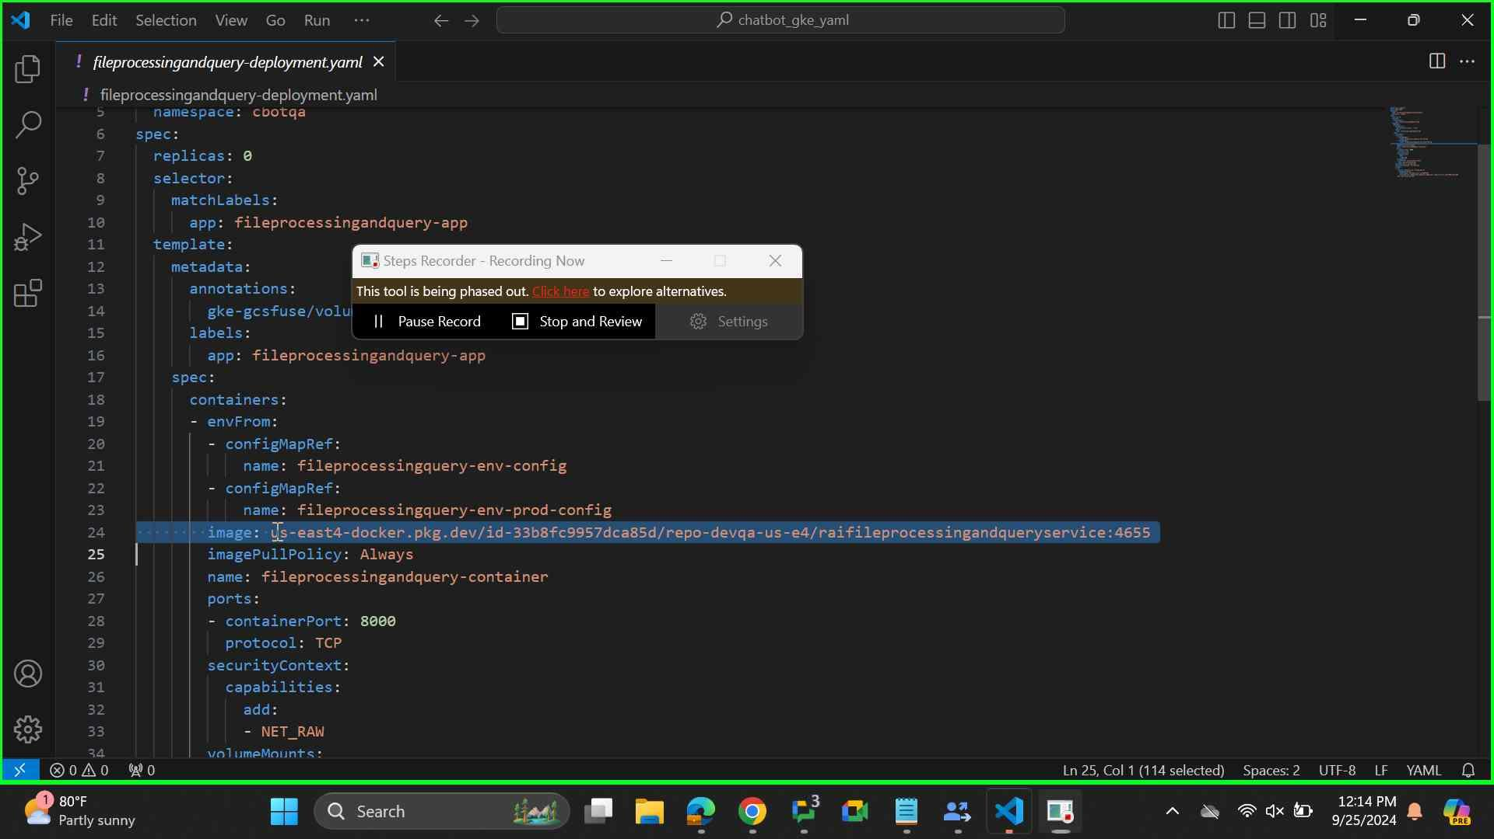

Step 3: Copy the updated YAML to the IAP desktop or from where you want to deploy and also take a backup of the deployment yaml or store in the centralize drive from where we can manage and retrieve the YAML. Now, run below commands to deploy the pods.

**Commands**:

kubectl deploy -f (deployment-yaml-name) -n (namespace)

with the help of above command we can deploy SVC, Pods,

kubectl get pods -n (namespace)

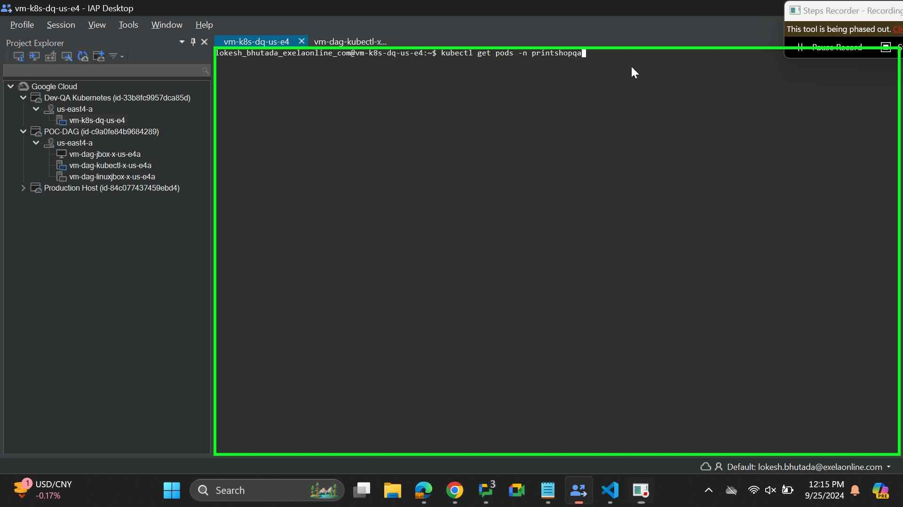

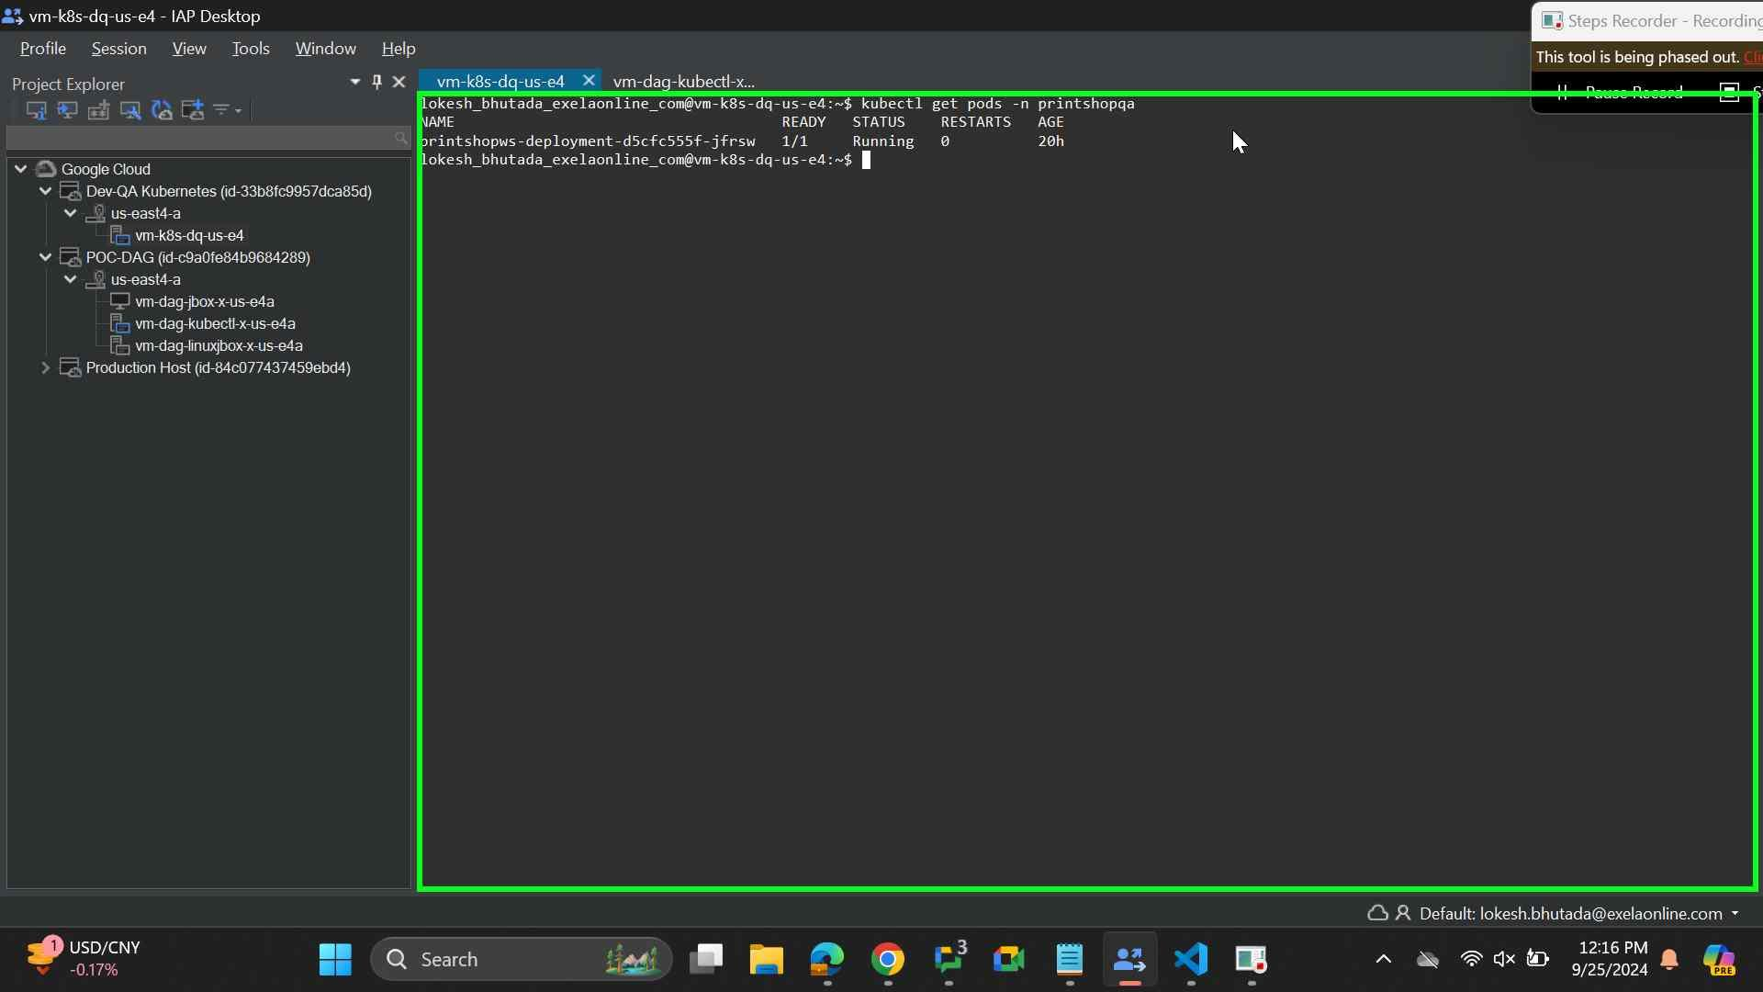

***End of Document***